GITLAB 1
Agenda
- Introduction
- Key Features
- GitLab vs GitBucket vs Bitbucket
- CI/CD Pipelines
- Setup of Gitlab
- Gitlab Dashboard Overview
- Architecture
- Terminology
- Creating Pipeline using Gitlab (Single Job)
- Multiple Jobs
- Negative Test Cases
Introduction:
GitLab is a web-based DevOps lifecycle tool that provides a complete set of tools for software development, security, and operations in a single application. It is designed to support and streamline every phase of the Software Development Lifecycle (SDLC)—from planning and source code management to deployment and monitoring.
GitLab helps teams reduce cycle time and improve developer productivity by consolidating tools, reducing integration issues, and enabling faster feedback.
Key Features:
1. Git Repository Management
- Create, fork, and clone Git repositories.
- Supports protected branches and tags to prevent unauthorized changes.
- Offers code browsing, history, and diff comparisons.
2. Built-in CI/CD Pipelines
- Automates testing and deployment through a flexible YAML-based configuration file.
- Runs pipelines using GitLab Runners, which can be self-hosted or shared.
- Supports stages, jobs, conditions, artifacts, and parallelism.
3. Auto DevOps
- Automates the entire lifecycle (build, test, deploy, monitor).
- Detects languages and frameworks automatically.
- Sets up pipelines and deploys to Kubernetes with minimal manual input.
4. Merge Request Reviews with Approvals
- Provides a collaborative review process for quality assurance.
- Enforces approval rules, pipelines before merge, and merge checks.
5. Container Registry
- GitLab provides a built-in Docker Container Registry:
  - Securely store and retrieve container images.
  - Integrate image builds into CI/CD.
  - Manage container tags and cleanup policies.
6. Kubernetes Integration
- GitLab integrates with Kubernetes for:
  - Auto-deployment
  - Monitoring and metrics
  - Cluster management from GitLab UI
- Simplifies cloud-native application deployments.
7. Wiki and Project Management Tools
- Each project can have its own Wiki (Markdown-supported) for documentation.
- Project management features:
  - Issue tracking
  - Boards and Epics
  - Time tracking
  - Milestones and labels
- Enables full collaboration and transparency across teams.
Benefits of Using GitLab:
- Single Application: Eliminates the need for separate tools like Jenkins, Jira, Nexus, etc.
- Automation First: Strong CI/CD capabilities out-of-the-box.
- Scalability: Suitable for individual developers, startups, and large enterprises.
- Security Built-In: Promotes DevSecOps by baking security into the pipeline.
- Transparency & Collaboration: All stakeholders work on a single, integrated platform.
GitLab vs GitHub vs Bitbucket:
Feature/Tool | GitLab | GitHub | Bitbucket
Primary Focus | Full DevOps lifecycle | Code hosting & collaboration | Code hosting & CI/CD (via Bitbucket Pipelines)
CI/CD | Built-in (native, powerful) | Available via GitHub Actions | Available via Bitbucket Pipelines
Open Source | Yes (GitLab CE) | Partial (some APIs, clients) | No
Self-Hosting | Yes (CE & EE) | Yes (via GitHub Enterprise Server) | Yes (Bitbucket Data Center)
DevOps Tools | Full DevOps toolchain | Limited native DevOps tools | Limited DevOps tools
Project Management | Built-in issue boards, epics, milestones | Issues, projects (basic) | Jira integration (strong)
Integration | Kubernetes, Prometheus, Terraform, etc. | Azure, Codespaces, Actions, etc. | Atlassian ecosystem (Jira, Confluence)
GitLab CE vs GitLab EE vs GitLab SaaS:
Edition | Description | Deployment | Use Case
GitLab CE | Community Edition – free and open-source | Self-hosted | Small teams, open-source contributors
GitLab EE | Enterprise Edition – includes advanced features for large organizations | Self-hosted | Enterprises needing compliance, SSO, auditing
GitLab SaaS | GitLab.com – hosted by GitLab Inc | Cloud-hosted by GitLab | Teams preferring cloud-based DevOps
CI/CD Pipelines:
- A CI/CD pipeline is a framework that integrates continuous integration, automated testing, delivery, and deployment.
- Designed to support agile DevOps teams, enabling iterative, reliable, and rapid code delivery.
Core Elements of a CI/CD Pipeline:
- Continuous Integration (CI)
  - Developers frequently commit code to a shared repository.
  - Automated builds and tests are triggered to detect integration issues early.
- Automated Testing
  - Validates performance, security, and correctness.
  - Helps catch bugs early in the SDLC, improving quality and reducing rework.
- Continuous Delivery (CD)
  - Code that passes tests is automatically staged for release.
  - Ensures code is always in a deployable state.
- Continuous Deployment
  - Automates the final step—deploying to production without human intervention.
Benefits of a CI/CD Pipeline:
- Rapid Feedback Short cycles and frequent commits allow early detection of runtime issues.
- Frequent Deployments Smaller, incremental code changes make frequent and safe deployments possible.
- Accurate Planning Increased visibility enables better roadmap forecasting and iteration tracking.
- Cost Reduction Automation reduces manual work and fixes bugs earlier, lowering long-term costs.
- Competitive Advantage Enables faster adoption of new technologies and customer-driven improvements.
Typical CI/CD Pipeline Stages:
A stage is a logical group of jobs that run in sequence during a CI/CD pipeline. Each pipeline is made up of one or more stages, and the jobs inside a stage run in parallel (if possible).
Common Stages in a Pipeline:
- build – Compile or package the application.
- test – Run unit/integration tests.
- deploy – Deploy to staging or production.
- release – Tag and release code artifacts.
Example .gitlab-ci.yml File:
stages:
- build
- test
- deploy
build-job:
stage: build
script: echo "Building the project..."
test-job:
stage: test
script: echo "Running tests..."
deploy-job:
stage: deploy
script: echo "Deploying application..."
Challenges of CI/CD Pipelines:
1. Environment Limitations
- Shared environments can create resource conflicts and configuration clashes.
2. Version Control Issues
- Pipeline dependencies must be version-aligned.
- Automatic updates can break compatibility and disrupt workflows.
3. Legacy Workflow Integration
- Legacy systems may resist change; careful planning is needed to avoid cascading failures.
4. Cross-Team Communication
- Teams often operate in silos.
- Poor communication can delay issue resolution and reduce pipeline reliability.
5. Additional Technical Challenges
- Inefficient test suites: Difficult to maintain and often incomplete.
- Manual database deployments: Complex and error-prone.
- Unplanned downtime: Pipeline failures delay releases.
- Rollback difficulties: Returning to stable versions can be hard post-deployment.
- Missing metrics: Lack of release performance insights.
- Static test environments: Diverge from production over time, causing inconsistencies.
Setup of Gitlab:
Step 1: Go to the website of Gitlab.
https://about.gitlab.com/
Step 2: Go to the Sign in option on the top right corner.

Step 3: Now, select the Sign in option.
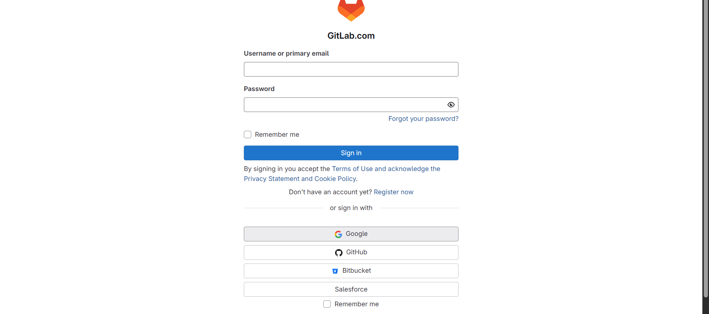
Step 4: Now, enter the details required.
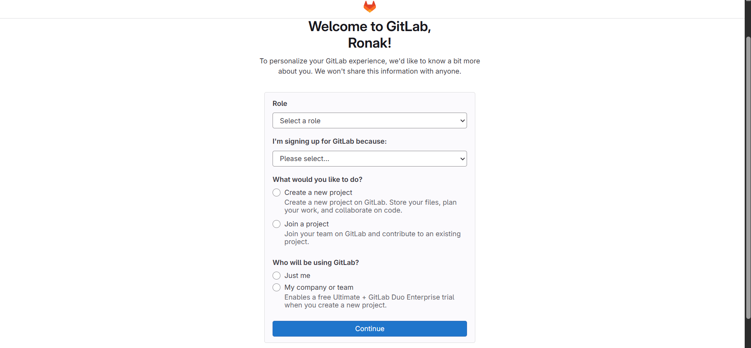
Step 5: Then, it will automatically create a project while starting, then Gitlab Web App will start.
Gitlab Dashboard Overview:
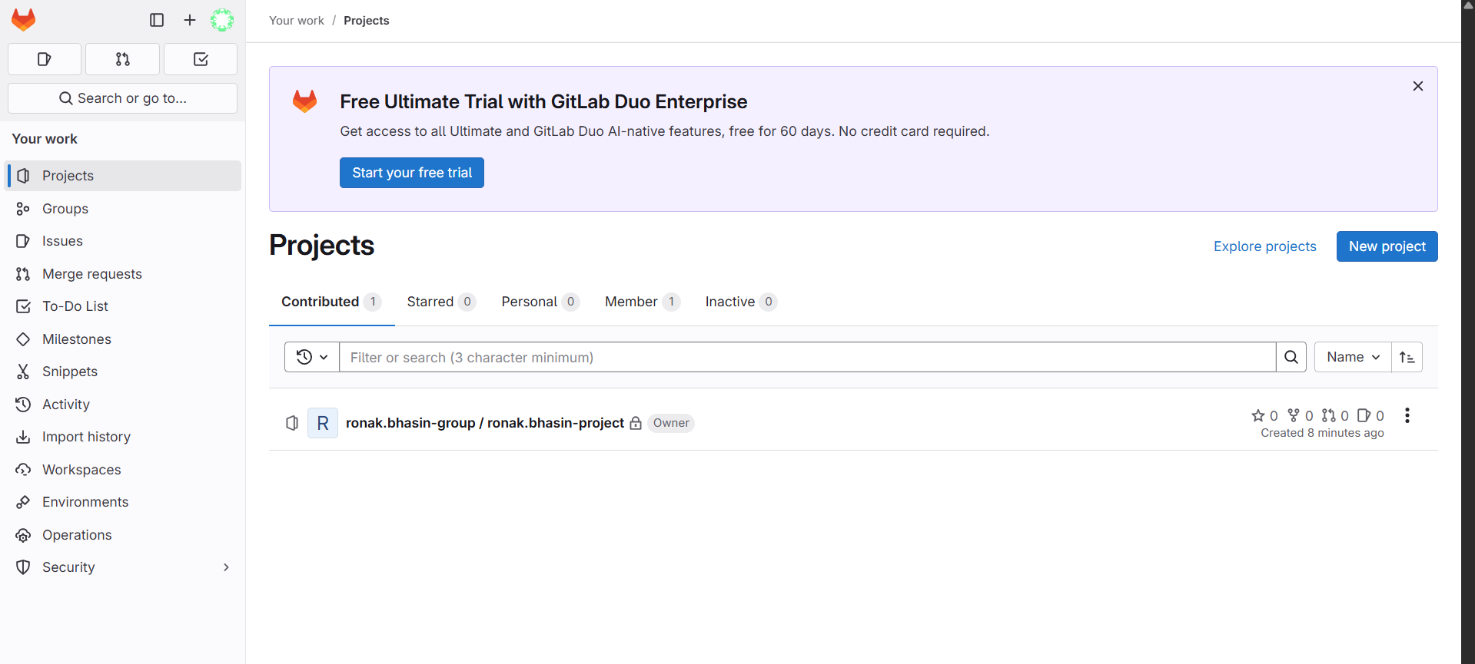
1. Projects Section
- Shows all the Git repositories you own or contribute to.
- Equivalent to "Repositories" in GitHub.
- From here, you can create a new project, import existing code, or explore other projects.
2. Groups
- Groups are used to organize multiple projects under a team or department.
- Comparable to GitHub Organizations.
3. Issues and Merge Requests
- Issues: For tracking bugs, tasks, or feature requests (same as GitHub Issues).
- Merge Requests: Like GitHub Pull Requests, used to review and merge code changes.
4. To-Do List
- Displays tasks or items assigned to you.
- GitHub lacks a dedicated "to-do" view, making this a unique GitLab feature.
5. Snippets
- Allows you to save and share small pieces of code (similar to GitHub Gists).
6. Activity Feed
- Shows your recent activities (commits, issues, merges).
- Like GitHub’s contributions graph and activity feed.
7. New Project Button
- Located on the right — allows creating a new repository/project.
- Functions similarly to GitHub’s "New Repository" button.
GitLab Architecture:
- GitLab is a monolithic application built primarily using Ruby on Rails and Go.
- Designed to offer a complete DevOps platform: version control, CI/CD, security, project management, and more.
- Can be used via GitLab.com (hosted) or self-hosted (GitLab CE/EE).
Core Components:
a. GitLab Rails App
- The main web application.
- Built using Ruby on Rails.
- Handles:
  - Web UI
  - API requests
  - Business logic (issues, users, projects, permissions)
b. Gitaly
- A service written in Go that handles all Git repository operations.
- Communicates with Git repositories directly.
- Replaces direct Git command calls for better performance and scalability.
c. PostgreSQL
- The primary database used by GitLab.
- Stores structured data:
  - User accounts
  - Issues, merge requests
  - CI jobs metadata
  - Comments, labels, permissions
d. Redis
- Used for caching and background job queues.
- Speeds up user sessions, job scheduling, and real-time features.
e. Sidekiq
- A background job processor using Redis.
- Handles asynchronous tasks like:
  - Sending emails
  - Processing CI/CD pipeline jobs
  - Repository imports
f. Workhorse
- A reverse proxy server written in Go.
- Handles HTTP(S) requests before they reach Rails.
- Optimizes performance for:
  - Large file uploads/downloads
  - Git clone/fetch over HTTP
g. Unicorn / Puma
- Application server for the GitLab Rails app.
- Unicorn was the default earlier; now Puma is preferred for multi-threading support.
How GitLab Handles Requests Internally:
1. User Request
- Sent via browser or Git CLI → hits Workhorse.
2. Workhorse
- Filters request (e.g., Git over HTTP) → passes to Rails App.
3. Rails App
- Handles user permissions, business logic, interacts with:
  - PostgreSQL (for data)
  - Redis (for session/cache)
4. Gitaly
- If it's a Git operation (clone, fetch, push), Rails sends it to Gitaly, which talks to the Git repo.
5. Sidekiq
- Long tasks (pipelines, notifications) are pushed to Sidekiq, processed in the background.
GitLab Terminology:
1. Repository (Repo)
A storage space for your project files and Git version history.
2. Project
A GitLab unit that contains a repository, CI/CD pipelines, issues, and settings.
3. Group
A container for multiple projects, used for organizing and applying permissions at a higher level.
4. Pipeline
A set of automated jobs that run in sequence/stages, often for CI/CD (Continuous Integration/Deployment).
5. Job
An individual task within a pipeline, such as compiling code, running tests, or deploying an app.
6. Runner
A lightweight agent that runs the jobs defined in .gitlab-ci.yml. Can be shared or specific to a project.
7. .gitlab-ci.yml
The YAML configuration file used to define the structure and behavior of CI/CD pipelines.
8. Merge Request (MR)
A request to merge code changes from one branch into another, often with a code review.
9. Branch
A copy of the code base used for development, bug fixes, or features before merging into the main branch.
10. Commit
A snapshot of changes in the repository, along with a message describing what was changed.
11. Issue
A task, bug, or feature request tracked in the GitLab project.
12. Milestone
A way to group issues and merge requests by a deadline or sprint goal.
13. Tag
A marker tied to a specific commit, typically used to label releases (e.g., v1.0.0).
14. Webhook
A way to send real-time data to external services (like Slack or Jenkins) when specific GitLab events occur.
15. CI/CD
Short for Continuous Integration/Continuous Deployment – automating testing and deployment of code changes.
16. Artifact
Files generated by a job (like test results or build packages) that can be saved and passed to later stages.
17. Fork
A personal copy of someone else’s repository that you can modify and suggest changes to via merge requests.
18. GitLab Pages
A feature for hosting static websites directly from your GitLab repository.
19. Protected Branch
A branch that restricts who can push or merge changes to it — commonly used for main or production.
20. Environment
A deployment target like staging, production, or test, used in CI/CD jobs to manage releases.
Creating Pipeline using Gitlab (Single Job):
Step 1: You need to create a file and name the file as .gitlab-ci.yml and then you will see various templates, for now don’t select any template.
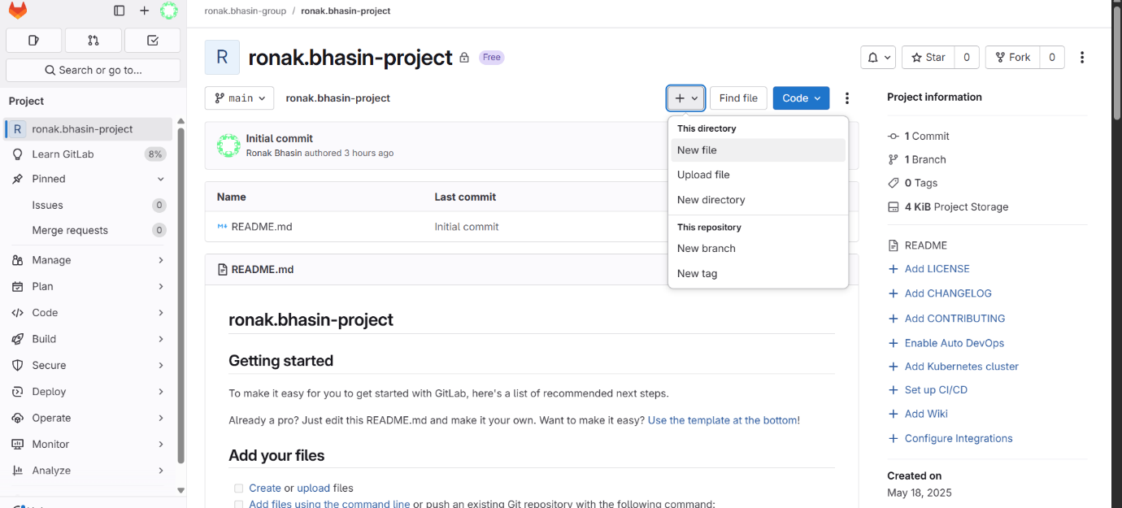
Step 2: Now, the jobs will be created in stages:
A. Build : Add this code for first job.
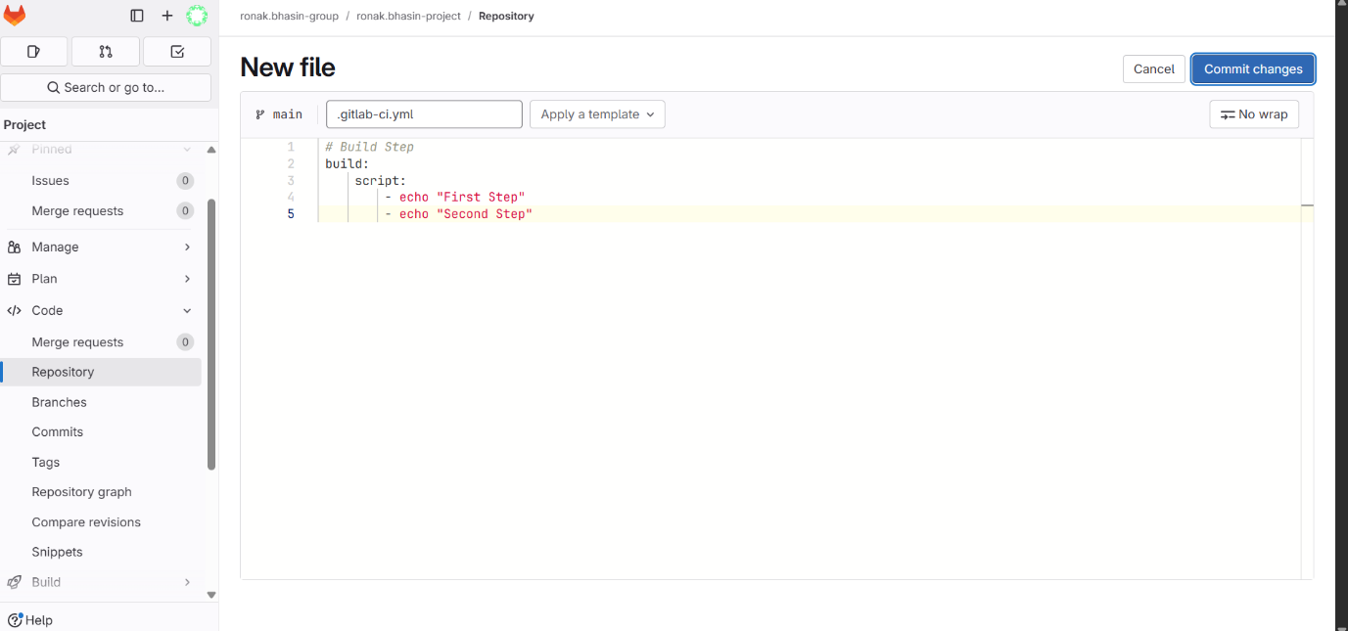
B. Then, save it by clicking on Commit changes option and enter the commit message.
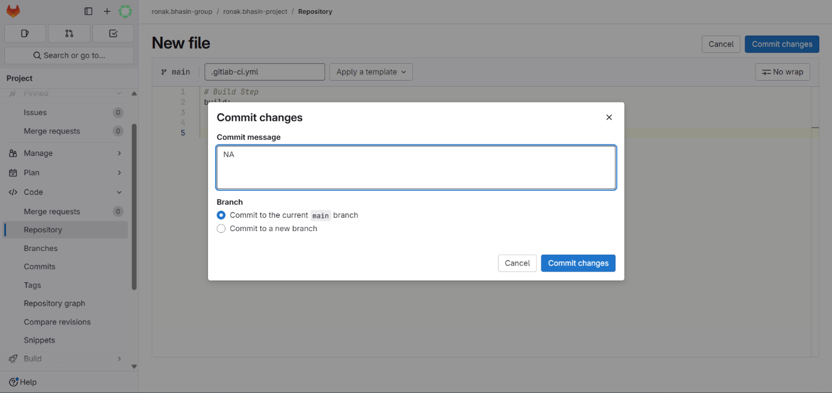
C. Now, the pipeline starts running, wait for it to run completely.
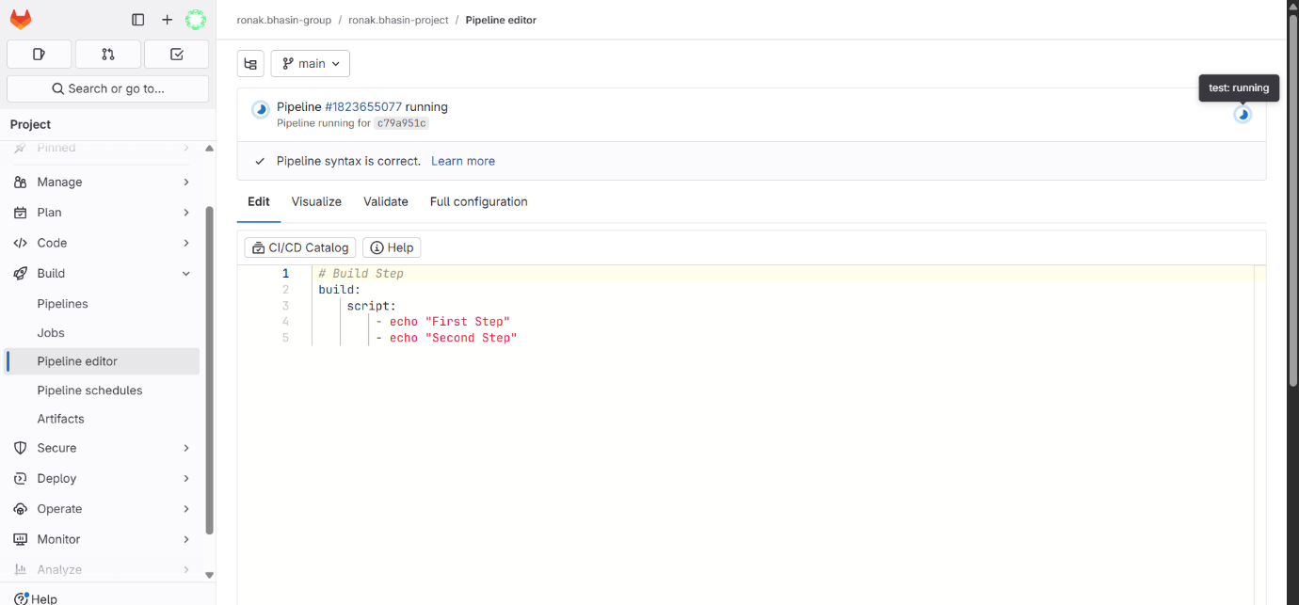
D. Now, the pipeline is created.
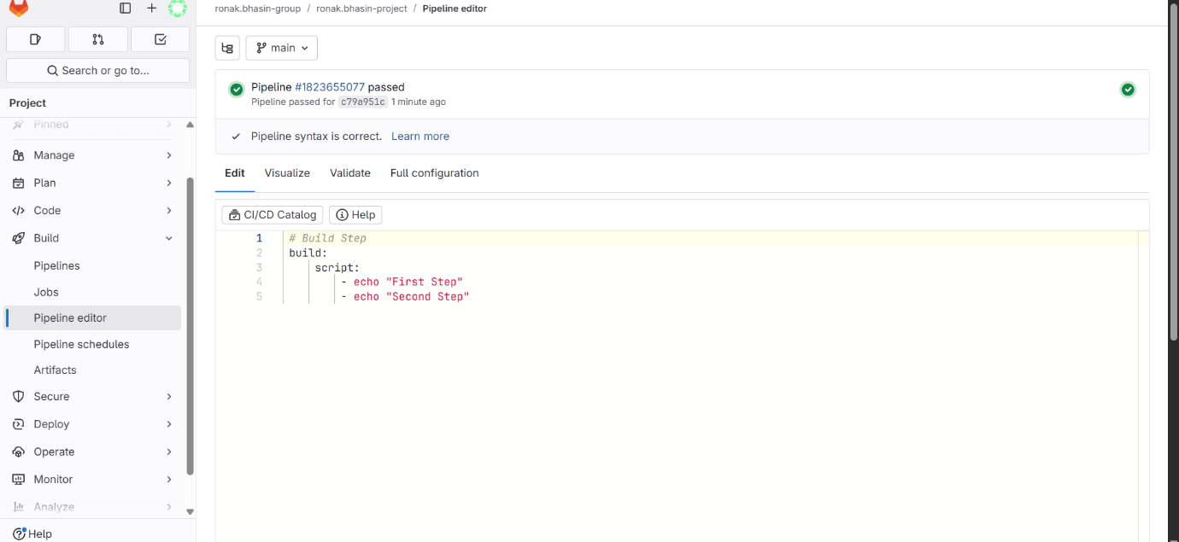
Step 3: Now, in this pipeline, the first job which is build is also passed.

Step 4: Now, click on this to see what is there on the backend.
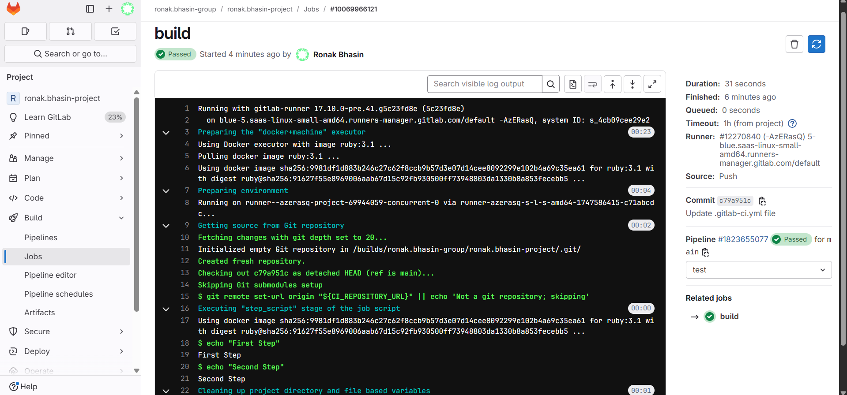
From here, you can understand, as soon as pipeline is created and jobs are passed, first runners are generated, then the environment is getting set up post that git repository is fetched and the job is executed.
Multiple Jobs:
Till now, only one job named build was created, now you will look into creating multiple jobs.
Step 1: Now, go back to the file and click on edit.
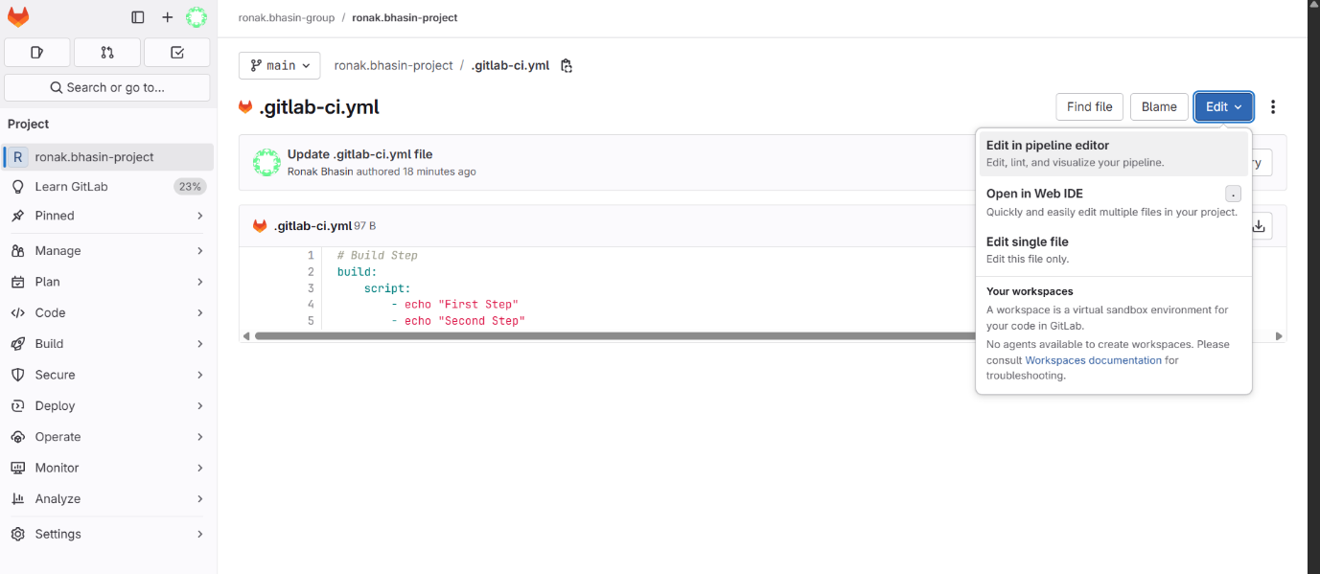
Step 2: Now, create two more jobs like this and wait for it to be passed and here you need to use a new command also which is stage as we want the jobs to run in specific order not together.
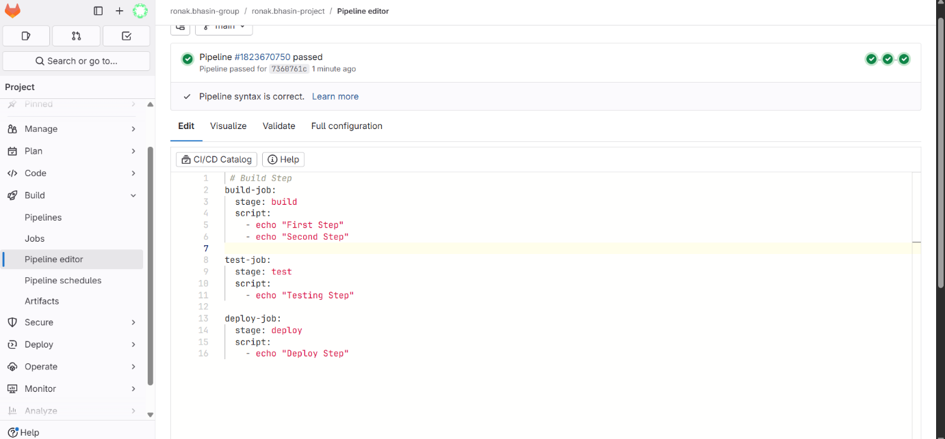
Step 3: From here, you can see the Jobs in various stages to be executed and on clicking any job you can see the logs of that particular job.
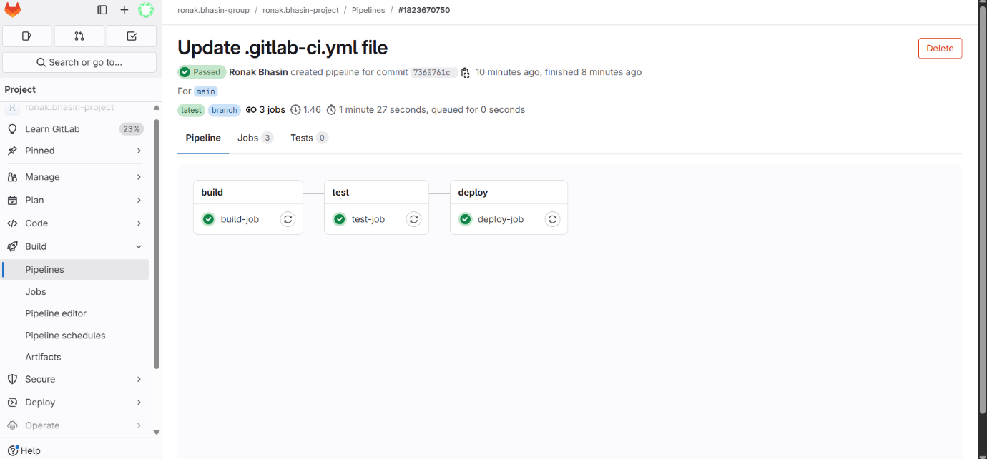
Negative Test Cases:
Negative test cases are designed to ensure your system fails gracefully when it receives invalid, unexpected, or erroneous input. They verify that:
- Errors are handled properly.
- The application doesn’t crash.
- Security and validation checks are effective.
Negative Test Cases in GitLab CI/CD:
In GitLab, negative test cases can be included in your automated test jobs within the CI/CD pipeline.
Example in .gitlab-ci.yml
Suppose you’re testing a Python app:
stages:
- test
negative-tests:
stage: test
script:
- echo "Running negative test cases..."
- pytest tests/negative_tests/
Here:
- You run negative test cases with pytest, which might check how your app handles invalid inputs or missing configs.
Runners:
A GitLab Runner is an open-source application used to run CI/CD jobs defined in .gitlab-ci.yml files. It picks up jobs from GitLab and executes them in the specified environment.
Types of GitLab Runners:
1. Shared Runners:
- Available to all projects in the GitLab instance.
- Managed by GitLab admins.
- Useful for general tasks across multiple projects.
2. Specific (or Group) Runners:
- Dedicated to a particular project or group.
- Offer more control over the environment.
- Useful for sensitive or project-specific setups.
Architecture of Runner:
